Reloaded: InterTech Rx
Technology - Expertise for Sustainable Solutions to Address Profitability & Environmental Concerns.

Chandler (USA, AZ), 15. September 2019. Rick Shaffer has restarted InterTech Rx, LLC. With his technology and experience in the plastics industry, he wants to focus on the pressing “Plastics Plague“ by collaborating to provide effective solutions to the needs of a circular economy.

InterTech Rx, LLC was first founded in by Rick Shaffer in 2010, to improve productivity and profitability by developing innovative and practical solutions for companies in the plastics industry. The industry veteran is leveraging his extensive know-how and decades long experience in plastics machinery and production systems. Now, Shaffer is expanding his scope to also include using his competence to provide a competitive advantage in key markets addressing economic and ecologic issues.

Services in the context of Sustainability.

For far too long, the plastics industry has claimed that plastics damaging the environment is mostly one of perception. The “Plastics Plague” segment of 60 Minutes demonstrated that plastics waste is a real and massive problem. Plastics waste and microparticles are found everywhere including the oceans, rainwater and even microorganisms. The impact on the environment is indisputable, says Shaffer. Shaffer believes “We created the problem; we need to take ownership and fix the problem” and is calling for the industry to move the needle toward Zero Waste. "Too many of us think that embracing the principal Reduce, Reuse and Recycle alone will somehow change the situation. Greenwashing will not get it done”. The key is knowing which will really work and above all how to effectively implement the solution. According to Shaffer, “Technology is the key to productivity and sustainability. Having an objective, holistic approach is the only way to make a difference. It will cost money and it won’t happen overnight, but we need to save our industry – in turn we help save the planet”. Shaffer wants to help companies navigate the maze of potential solutions and choose the best and most cost-effective way to start.

Shaffer sees and increased demand for a variety of sustainable solutions for medical and packaging products. Many companies have cut back on internal resources and are now missing both know-how and experience. His goal is to fill in the gap left since the need remains. Whether it is in the area of strategic planning, productivity improvement, product improvement or M&A support, “having ideas and visions is important. Knowing what really works and how to implement it is essential for turning dreams into reality”.

His many years of international experience – particularly for effective, practical solutions in the medical and packaging branches – will be interesting for growth oriented companies.

For further information, please contact InterTech Rx, LLC or visit www.intertechrx.com. Contact Rick Shaffer through LinkedIn or by telephone at (480) 231 90 22.

Background
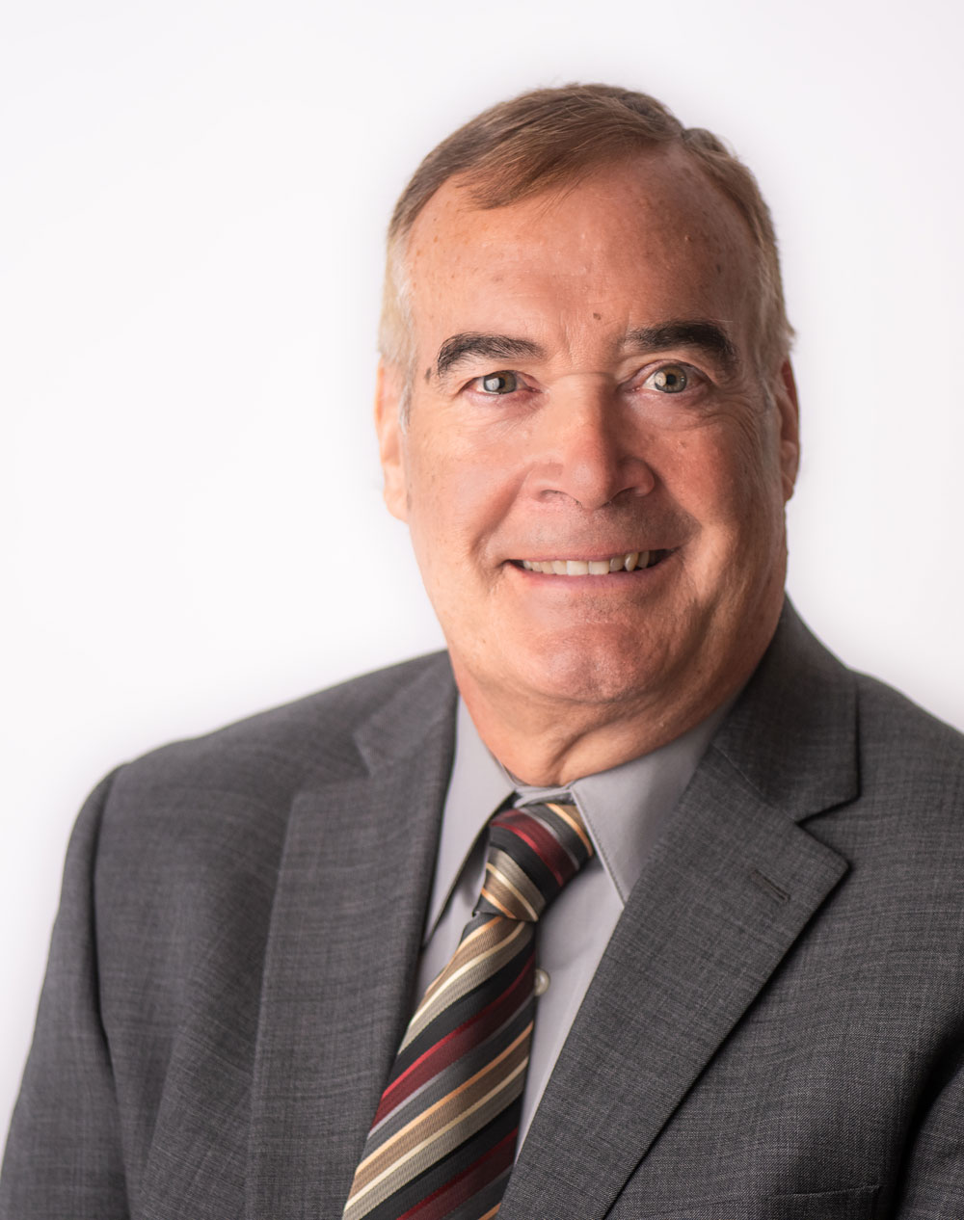
Shaffer began his journey in the plastics industry at Beloit back in the late 70’s in the engineering department and continued on with their transition to Deacon plastics in 1981. He was recruited by Demag Kunstoff Technik in 1983 to start plastics operations for the German company in the USA where he built their North American presence to the point when they acquired Van Dorn. He continued with Demag for a total of nearly 20 years until he took over as president of Netstal USA in 2002. He transformed Netstal USA to recover from the dying CD & DVD market and transformed them to a supplier of high-performance packaging system solutions including the first high cavitation IML systems in the USA.

Shaffer’s career turned to the other side of the table when he joined Flextronics in 2013 to build up their precision plastics capabilities and was a key member of the management team to implement their international strategy as a strategic supplier to the medical industry with a dual focus on tooling and manufacturing services.
Westfall Technik was the next challenge which began with the founding of the company in September of 2016. Shaffer was one of the three-member core management team to establish and implement the M&A strategy with meteoric growth in tooling and contract manufacturing until March of 2019.

Intention und Position
It is my hope and desire to make truly sustainable solutions a significant part of my focus. I believe that we in the plastics industry need to take the lead in curing the “Plastics Plague” that we have created instead of just “Greenwashing” the issue. The truth is that anyone who saw the recent 60 Minutes piece should be shocked into action. If we don’t implement an effective solution soon, there will be increased legislation to do so. The problem is that the legislation will be created by people who are not competent to establish the right concept and is likely be much more expensive and even more likely be ineffective in moving the needle. Banning plastic bottles at San Francisco Airport won’t help much but doing nothing is equally irresponsible.

There will not be an easy or cheap solution and there will certainly not be just one solution. The ocean pollution should be a wake-up call to be sure but there are other “unseen” issues that will become center stage in the future. Plastics that beak-down into microscopic particles don’t really disappear and they too will be in the ecosystem. We should not see the Reduce, Reuse and Recycle as an order of priority, we need to do all of them. We also need to recognize that we all need to take a holistic approach. For example, recyclable does not mean recycled, otherwise there would never be a water bottle found in the ocean. Reduction of resources can be effective but is trading a glass bottle for an unrecyclable pouch a good choice? Similarly, reuse justification will be dependent on the number of times it is reused. The bottom line is that a comprehensive life cycle analysis needs to be combined with a feasibility study to be effective.

What will it take to achieve true sustainability? For the world of food packaging, there is currently no solution that can check all the boxes. It will take new technology or a combination of technologies and some development work along with iterative testing. It will come at a cost, but ineffective legislation will too.
It will take commitment to succeed and not just more “Greenwashing” or eco-friendly initiatives with nothing behind it.

A Dream is a Vision without a Plan…
… A Vision with a Plan is an Initiative…
…… An Initiative without Execution and Commitment is a Delusion!

We need to start somewhere so at least make zero waste a real and measurable goal. Start in your own facility and objectively determine where you are with zero waste. Every pound of plastic that comes in the door should leave as good parts and you need to know what really happens if it doesn’t. You may not be able to make it perfect, but you can make it better.

